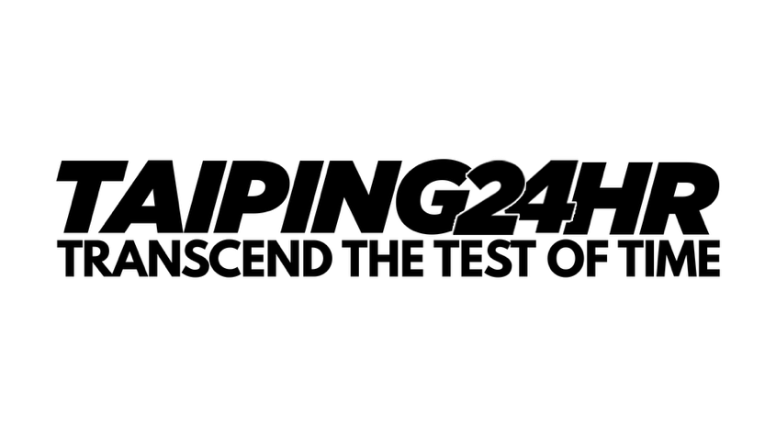

**WAIVER FORM**

I, __________________________________ (Full Name, ID / Passport no.) the legal guardian to _____________________________ (Full Name, ID / Passport no.) hereby authorized him/her to participate in TAIPING 24-HOUR 2026. I will ensure that he/she is accompanied by me or an appointed guardian by me and will not hold the organizer responsible for any eventualities.

________________________________

Signature of Runner’s Guardian