MILE 27 TRAINING PROGRAM

THE NORTH FACE® MALAYSIA MOUNTAIN TRAIL FESTIVAL 2023 SPECIFIC TRAINING PLANS
By: Coach Simon Peter Byrne (simon@mile27.com.au)

The following training plans are intended as a guide to preparing for THE NORTH FACE® MALAYSIA MOUNTAIN TRAIL FESTIVAL 2023 50KM Ultra Challenge and 100KM Ultra-Trail® Challenge. It is recommended that any aspiring athlete has already a solid running base and some experience over shorter distance trail running. Rapid increases in training volume can lead to overuse injuries. Regular rest days and easy effort runs are important.

- In beginning this schedule, you should feel comfortable currently running approximately:
50KM event - 30-40KM / 100KM event - 40-50KM without injury.

- Maximum volume weeks will be approximately 60-80KM (50KM) or 80-100KM (100KM).
(If you engage in this training plan you agree that you do so at your own risk, are voluntarily participating in these activities, and assume all risk of injury to yourself. You should consult your physician or other health care professional before starting this or any other fitness program to determine if it is right for your needs)

SPECIFIC RACE NOTES:

- Specific to suit: 50KM (2960m) and 100KM (5330m) THE NORTH FACE® MALAYSIA MOUNTAIN TRAIL FESTIVAL 2023 course.

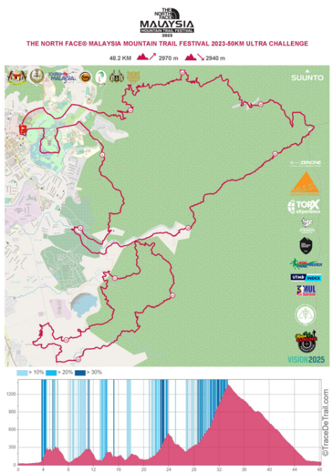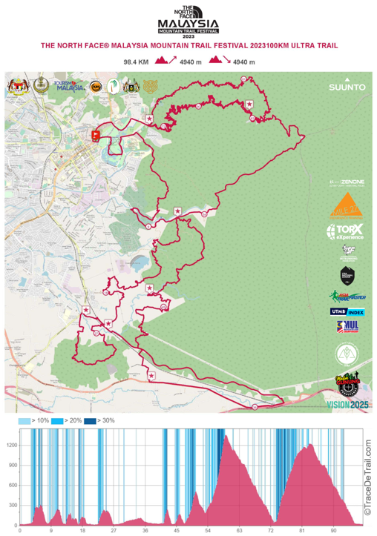

- In early stages the course is undulating but with no big/ long climbs

- Latter stages both 50 & 100KM have significant vertical ascent AND descent.

- 50KM has 1 x big 1000m climb (approx.) / 100KM has 2 x big 1000m climb (approx).

THEREFORE, VERY STEEP IN SECTIONS: GAIN NOT EVENLY DIVIDED OVER WHOLE DISTANCE

Terrain:
50km: 65% Trail /35% Road
100km: 75% Trail / 25% Road

Terminology used in these training plans:

Warm up and warm down:
ALL HILL AND TEMPO SESSIONS BEGIN AND END WITH:
- Warm up and down with 10-15 mins of easy slow running.
- Warm-up: after 10 mins add 7 x 20 secs “Strides” (gradual increase in speed to 80% max and gradually slow down).

Speed /Tempo session:
Effort:
- Rate of Perceived Exertion (RPE): 6/10.
OR
- Pace that can be held consistently for 40-50 mins.
OR
- 10 km race pace.
(e.g., 50mins = 5 min/km)
OR
- able to speak in short sentences.

Easy runs:
- Super easy effort or “active recovery”. These runs are base-building aerobic runs.
- Save legs for Tues and/or Thurs hard efforts: specificity and quality sessions.

Hill Descriptions:
Type 1) Slight hill: 3-6% gradient (fast)
Type 2) Medium hill: 6-12% gradient: (able to run with effort, can hike also)
Type 3) Steep hill: 12%+++ gradient (hiking)

Hill Descent technique:
- fast, short stride length
- light on feet
- avoid over-striding

Long Runs:
- Easy effort, similar to recovery runs but over progressively longer durations of time.
- conditioning the body physically AND mentally to be “out there” for long periods of time.
- Opportunity to use as a “dress rehearsal” for race day.
- Experiment with nutrition/ hydration, mandatory kit, anti-chaffing products, and new equipment (shoes/ packs/ shorts/ socks etc). “Nothing new on race day!”

B-2-B (Back-to-back runs):
- All running (no hiking)
- Relatively flat/undulating
- Not steep
- Promotes running on tired legs.
- Particularly good for “those sections that you know you really should be running in latter stages of race”.

REST DAYS
- Rest days are a crucial part of a training schedule as they allow the body to recover and strengthen. Managing fatigue is an integral part of a balanced training plan and plays an important role in preventing injury.

Malaysian Mountain Trail Festival: 50 km& 100km training program.
https://youtu.be/I3GqZMMDk3E 50KM https://youtu.be/qR0qqW_5UHA 100KM :
2960m for the 50KM and 5330m for the 100KM.

