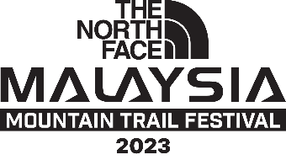

WAIVER FORM

I, __________________________________ ( Full Name, ID / Passport no. ) the legal guardian to _____________________________ ( Full Name, ID / Passport no. ) hereby authorized him/her to participate in Malaysia Mountain Trail Festival 2023. I will ensure that he/she is accompaniedby me or an appointed guardian by me, and will not hold the organizer responsible for any eventualities.

_______________________
Signature of Runner’s Guardian

