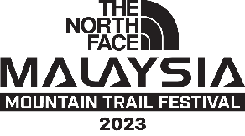

AUTHORIZATION FORM

I am unable to attend Malaysia Mountain Trail Festival 2023 and hereby authorized_____________________________ (Full Name, ID / Passport no.) to collect the race pack on my behalf.

I acknowledge that in the event of an absence of the authorization form and my email confirmation, the organizer reserves the right to refuse collection of the race pack.

I hereby declare that this Letter of Authorization, along with the supporting document has been confirmed as being authentic.

Signature:
Runner’s Full Name:
Runner’s ID / Passport:
Date:

